# Probability and Statistics

### Content

### Introduction

#### How do Probability and Statistics help?

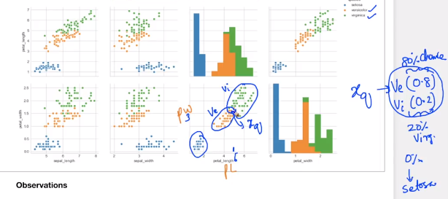

Our task is classification but we are not able to exactly classify, so instead of being very decisive what if we are able to give the probability of chance that it belongs to Ve or Vi

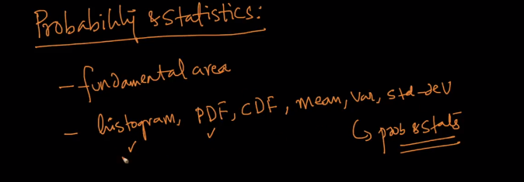

Even we learn then in EDA they are basics in Probability and Statistics

#### Random Variable

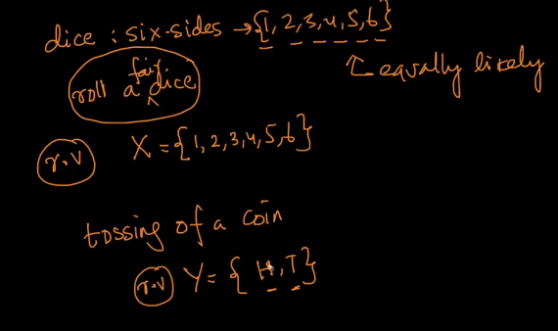

Random Variable is generally mentioned in Capital X, Y …

#### Notation for the probability of r.v taking a value

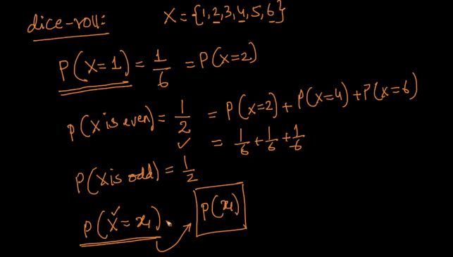

P(X=x1) We read this as the probability of a random variable X taking a value of x1. In short, as we know that X is a random variable we use P(x1)

#### Discrete random variable and Continuous random variable

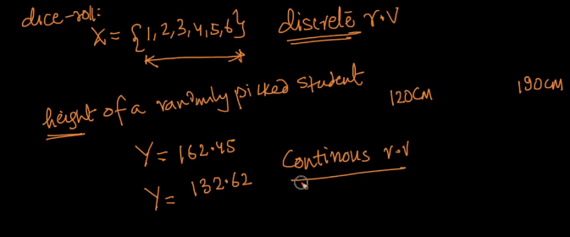

Discrete Random Variable: A Random Variable that can take from a finite set of values is called a discrete random variable.

Continuous Random Variable: A Random Variable that can take any real value in the above case

#### Outlier

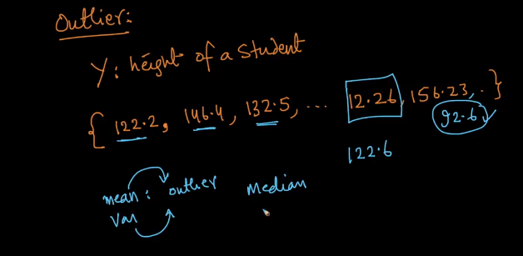

### Population and Sample

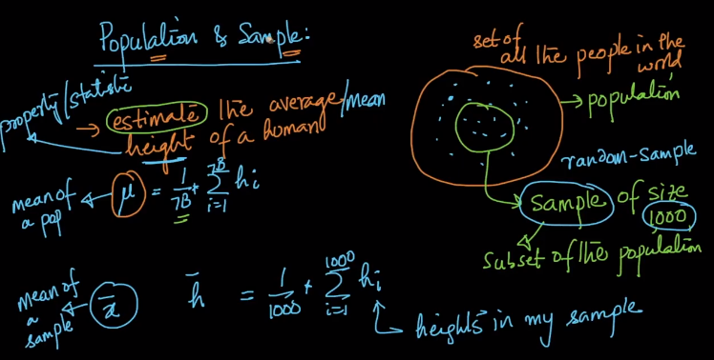

Task: to find the average height of the entire 7B population

As the number is very high we might not be able to calculate each and every person height and get the mean, so we take a random sample of 1000 (i.e subset) of population.

Now we estimate the average/mean height(i.e property/statistic) of the human using the sample

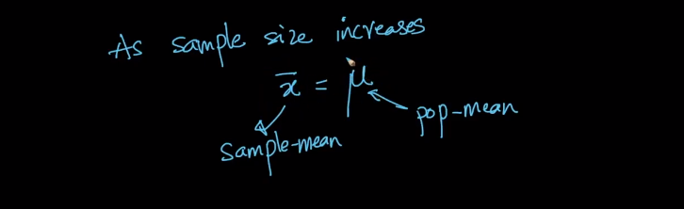

As the sample size increases then the sample mean converges to the population mean.

### Gaussian/Normal Distribution and its PDF

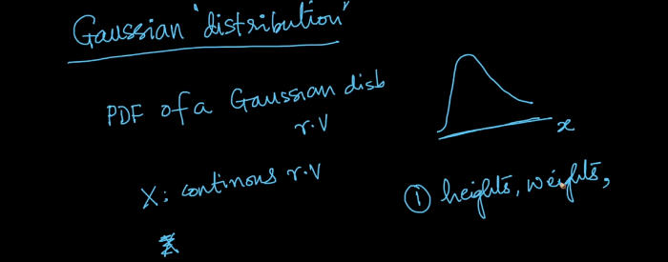

Let consider a random variable X which has a PDF like a PDF then we say X has a Gaussian distribution.

A lot of things in nature follow Gaussian Distribution. Example heights, weights of people

Why do I learn about distribution?

In short, distributions are very very simple models of natural behavior.

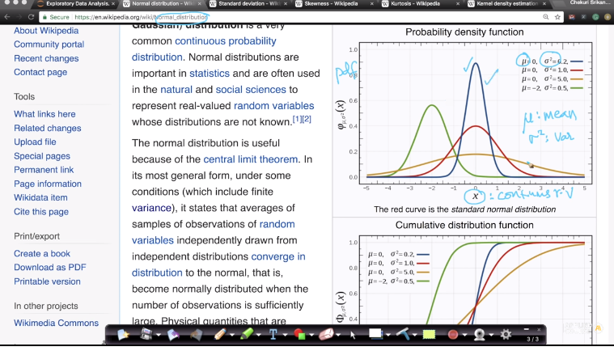

If random variable X follows the Gaussian distribution and if you give me mean (μ) and variance (𝞂2) then I can tell what it's PDF.

Mean and variance is called parameters of the distribution.

As soon as I know the PDF then I can get the CDF so on.

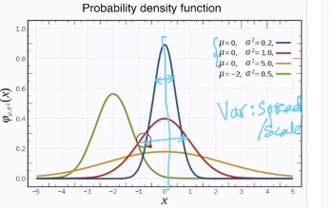

Variance is the measure of spread/ Scale.

As variance increases then PDF is going to get fatter and shorter.

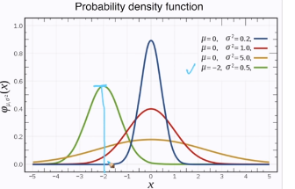

In a Gaussian Distribution then the peak is mean(μ).

In a PDF the height represents how often we find these points

#### Notation

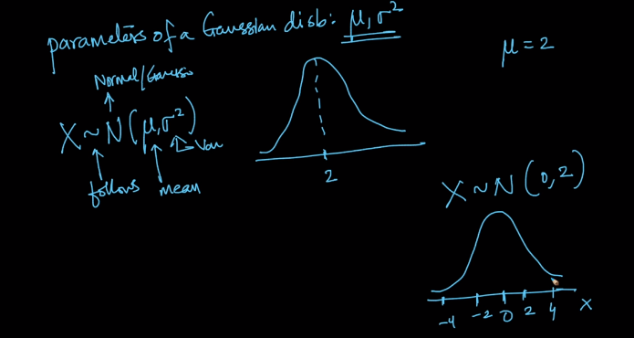

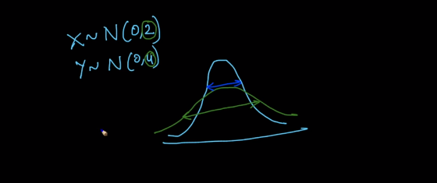

#### Mathematical Notation

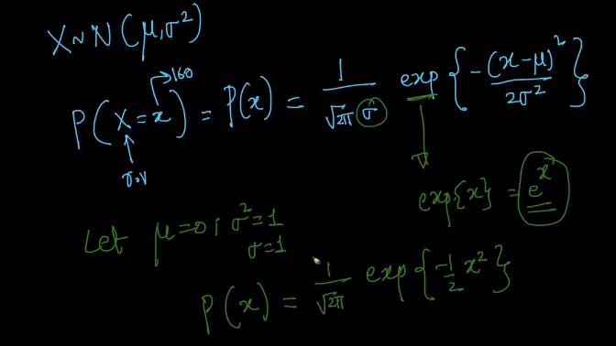

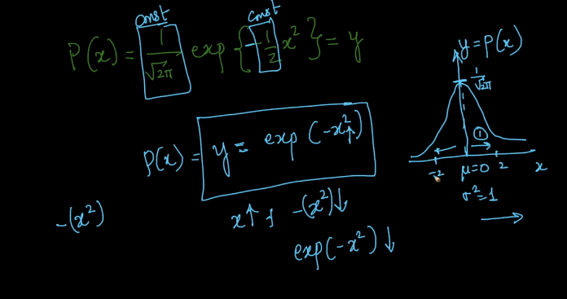

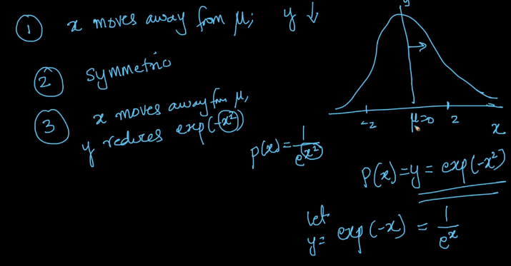

1. x moves away from mean then y decreases
2. Symmetric: Whether x= 2 or x =-2 the value doesn’t change so it is symmetric.
3. x moves away from mean then y reduces exponential quadric drop

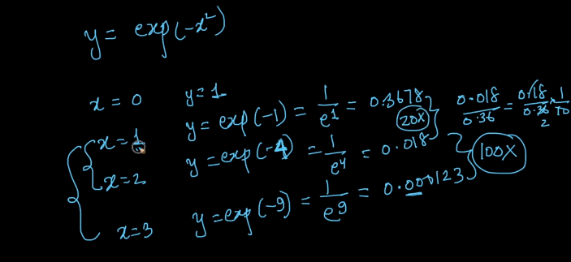

As shown above even x changes from 1 to 2, y reduces quadratically

### CDF(Cumulative Distribution function) of Gaussian/Normal distribution

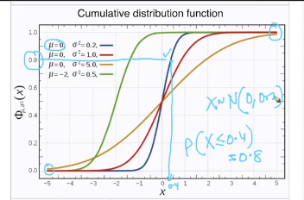

CDF will always range from 0 to 1.

The left bottom is always at 0 and the right bottom is always at 1.

Let's consider the blue curve.

For a given point on the curve, what does the height represent in this curve?

Probability of a random variable X is less than or equal to 0.4 is 0.8

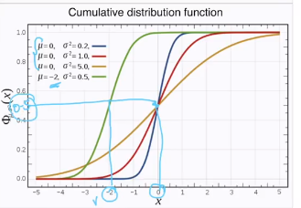

If μ=0 then corresponding y value will be half (0.5), as this is symmetric half lie on one side and the other half lie on another side.

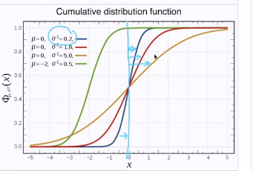

If the variance increase then CDF moves farther and farther away from X=0

### Standard Deviation

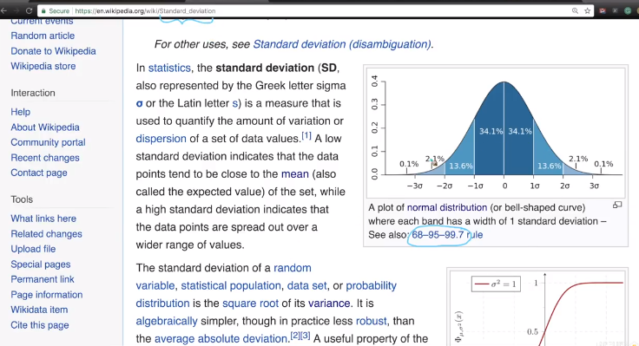

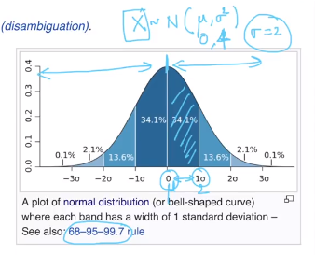

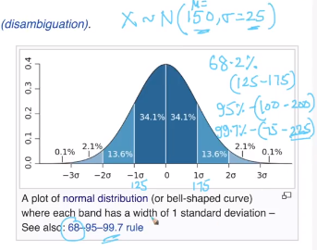

Example: Heights of population

Let's say for a random variable X following Normal distribution with a mean of 150 and a standard deviation of 25 then

As shown above, 68.2% have a height of 125-175 for 1st standard deviation, so and on so forth

### Symmetric distribution, Skewness, and Kurtosis

<https://www.statisticshowto.datasciencecentral.com/probability-and-statistics/skewed-distribution/>

All the above properties help us understand the shape of the distribution, especially PDF.

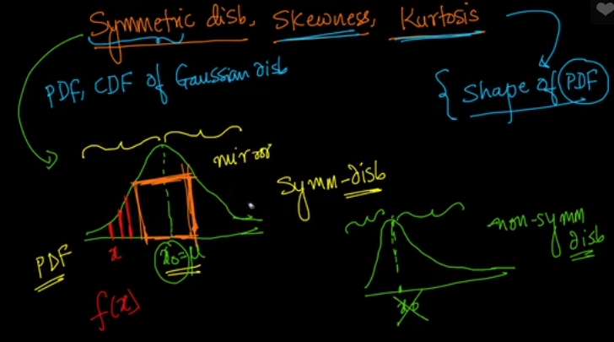

There exist a point if we see the mirror image on the left side and right side

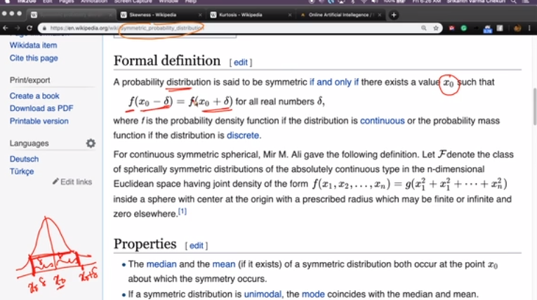

f here represents the height of PDF at any point x

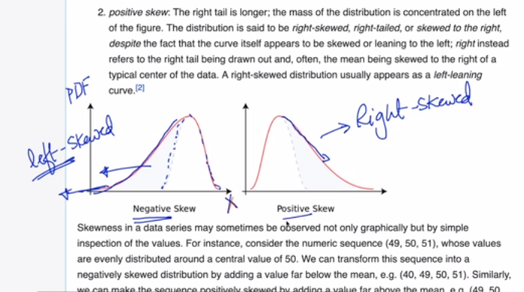

Tailed distribution or skewed distribution

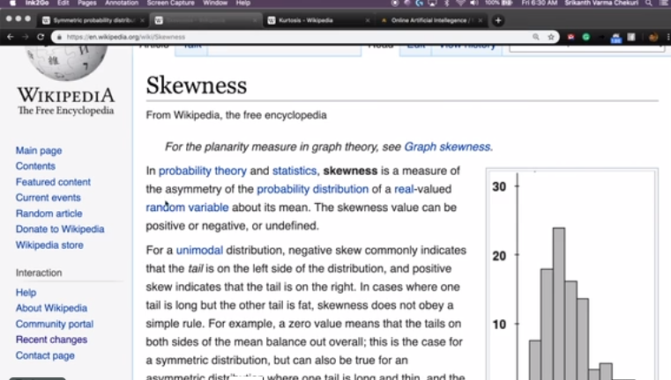

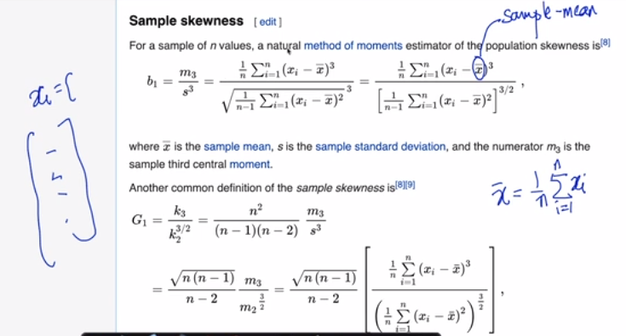

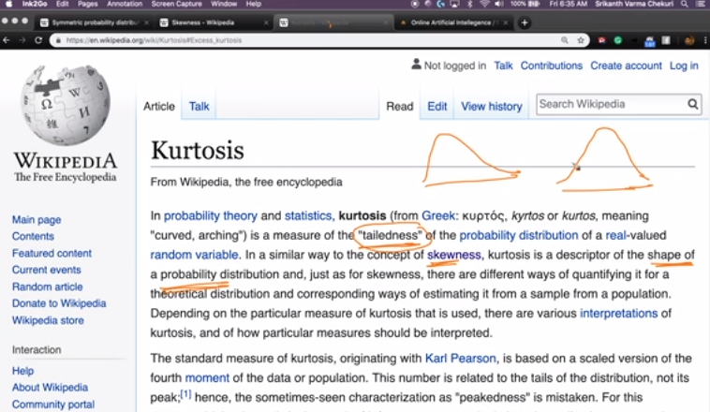

This tells me additional information about the shape.

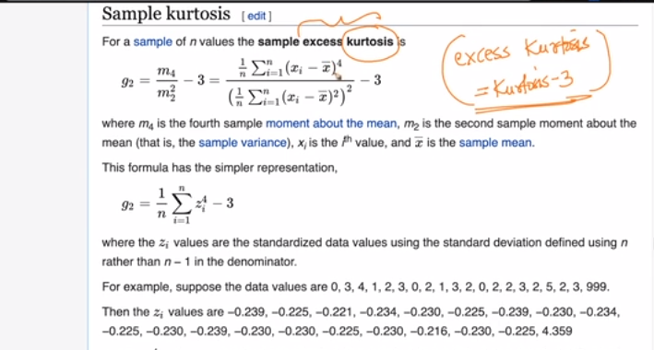

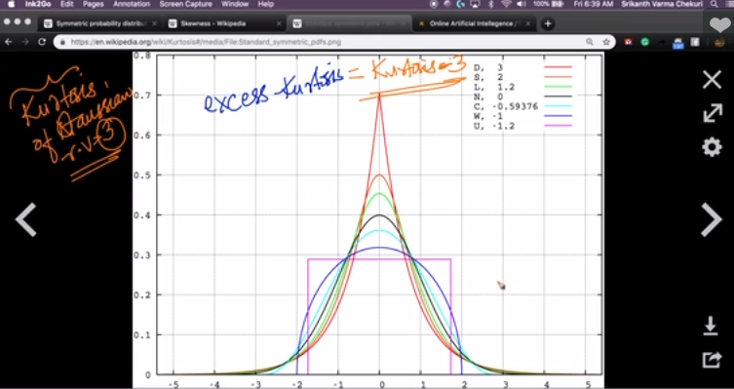

Kurtosis of Gaussian Random Variable is 3

The Reason for 3 is we are measuring through excess kurtosis, how different the shape of distribution from the shape of Gaussian distribution whose value is 3

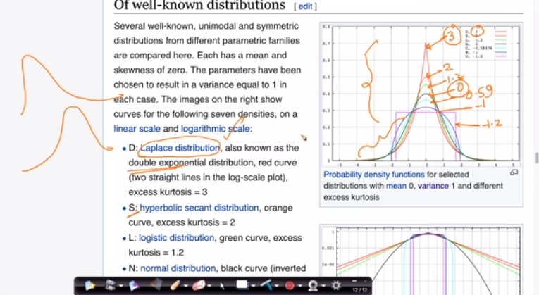

Kurtosis is a measure of tailedness but not peakedness

Kurtosis is useful in our outlier measurement in the observation we have.

### Standard normal variate (Z) and standardization

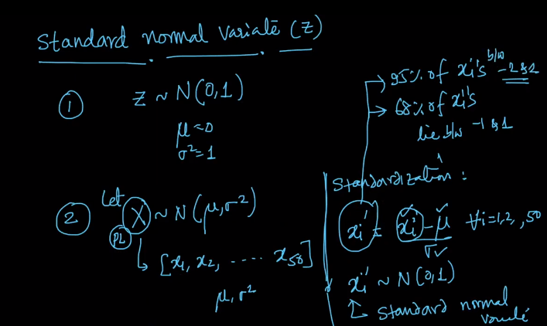

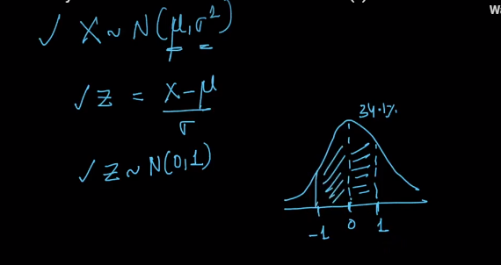

Given any random variable for any mean and variance, we can get the standard normal variant that will lie between -1 and 1

### Kernel density estimation

Kernel density estimation is a technique to smoothen the Histogram that will give a PDF.

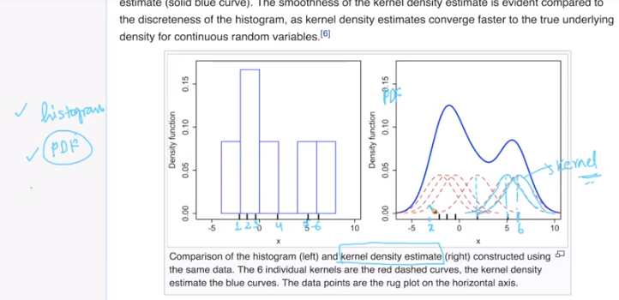

Lets’ consider 6 points in Histogram and for each point plot a Kernal perpendicular to the point.

To find the height of x on PDF we sum all the Gaussian Kernal points at that point.

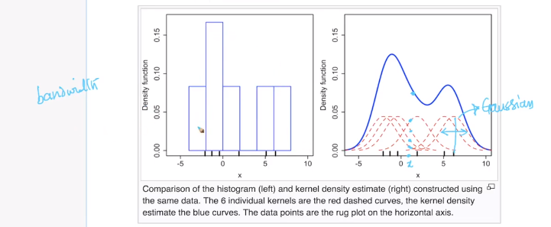

Variance is also called a bandwidth in Gaussian Kernal

As the number of bins or window size increase, these graph becomes more jagged

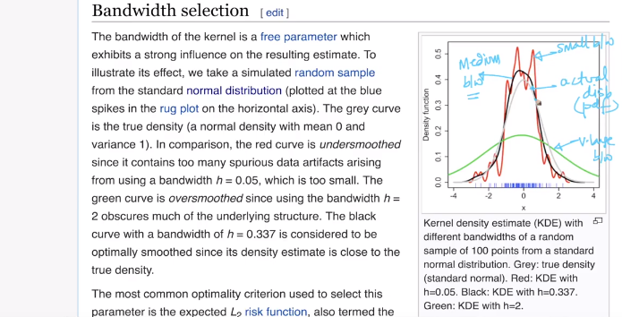

Intuitive what seaborn does is they choose a very small bandwidth and they keep on increasing till it is smooth but not too flat.

### Sampling distribution & Central Limit Theorem

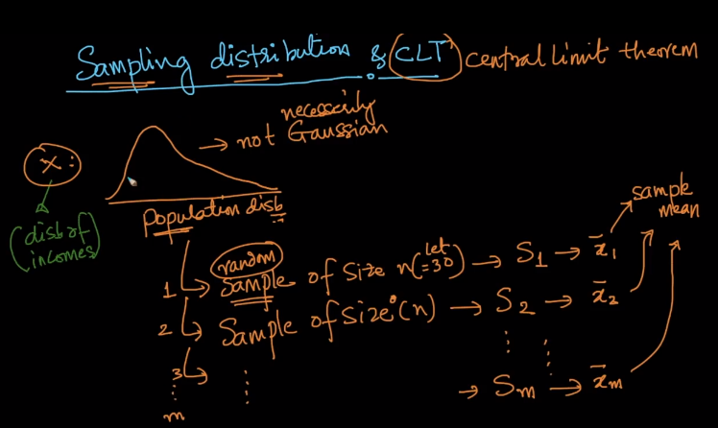

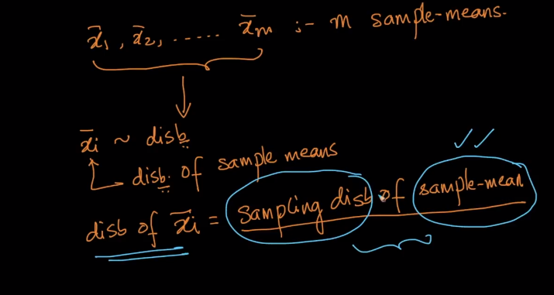

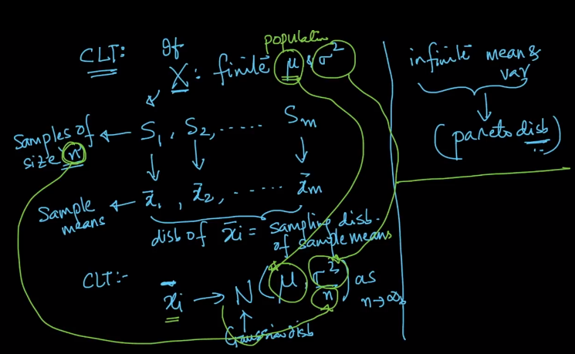

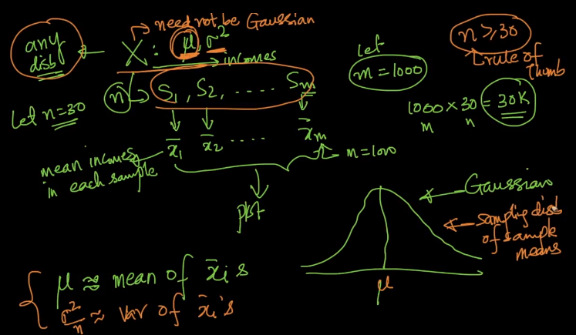

CLT says for any distribution with a finite mean and finite variance is a Gaussian distribution with a mean tending towards the actual mean and the variance is sigma square by n as n tends to infinity but as soon as n >= 30 then these things will get falling in place

### Q-Q plot: How to test if a random variable is normally distributed or not

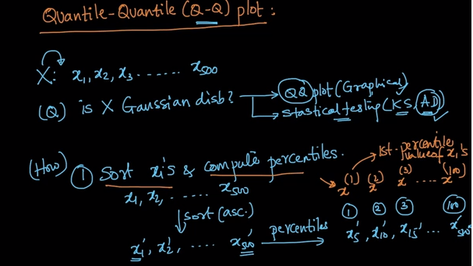

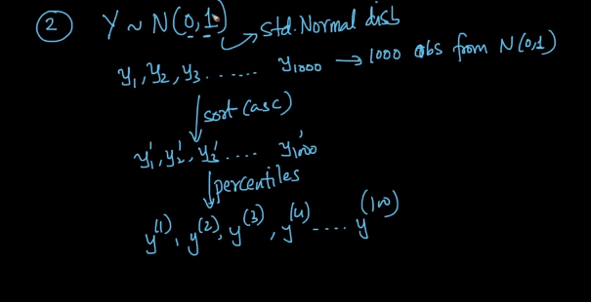

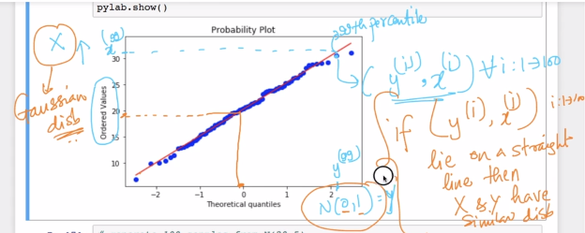

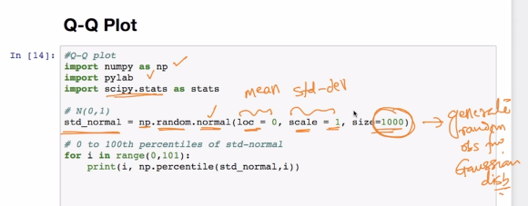

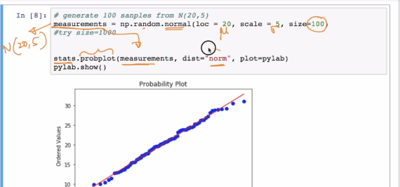

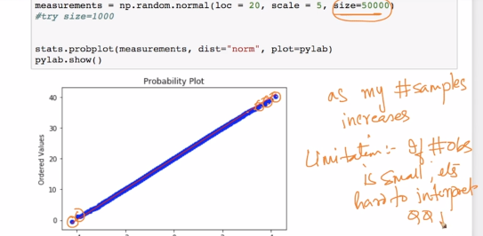

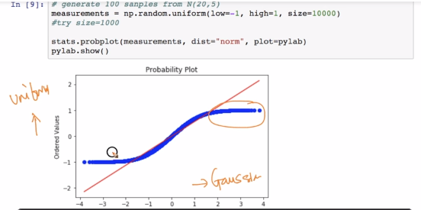

If all points lie on the straight line then we can conclude that the distribution on x-axis and distribution on the y-axis are from the same family.

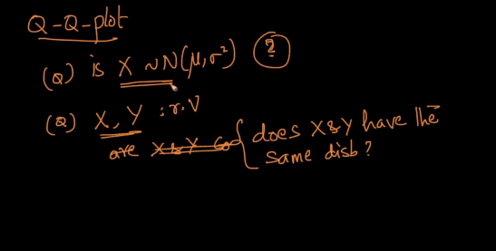

Q-Q plot helps us to answer the above questions

### How distributions are used?

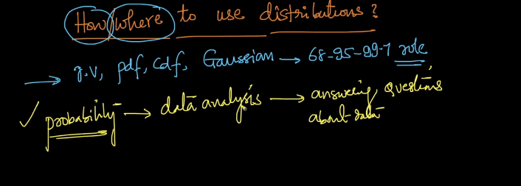

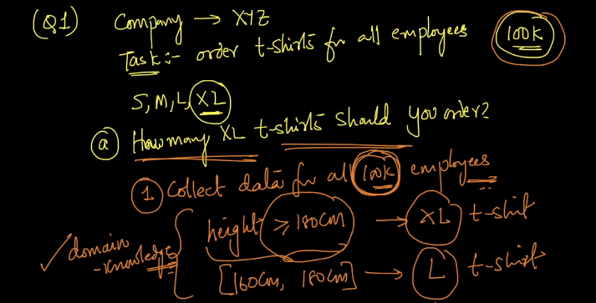

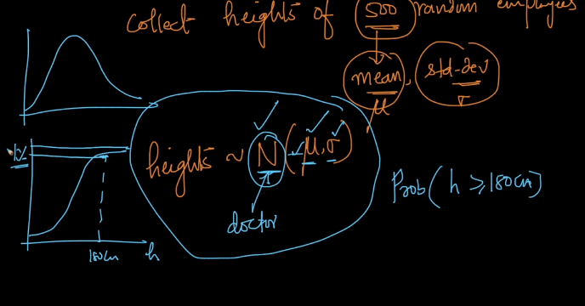

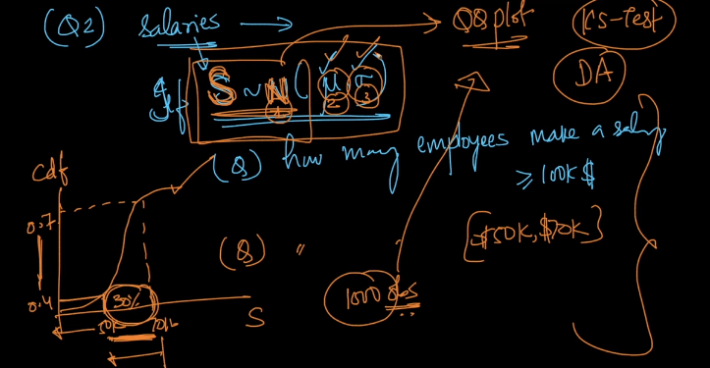

### Chebyshev’s inequality

https://youtu.be/GMDvuzfNxzI

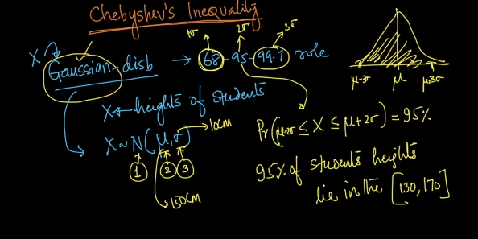

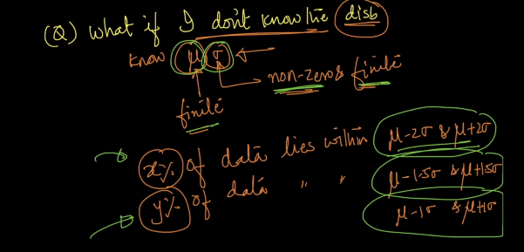

If I don’t know the type of distribution but I know that mean is finite, the variance is non-zero & finite. Can I find x% of data for 2 standard deviations?

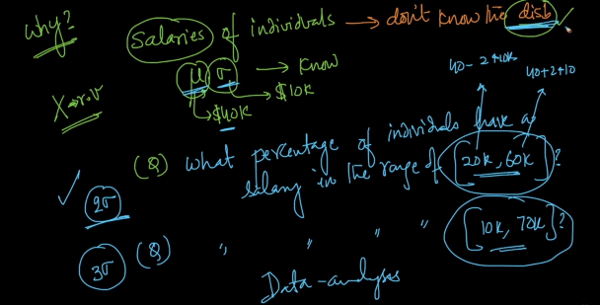

If this is Gaussian distribution then it would be very simple where for two sigmas we get 95 %

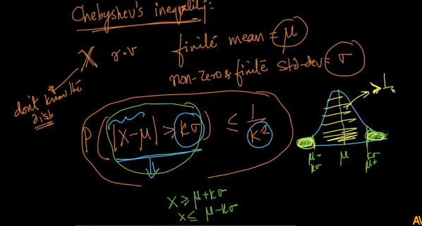

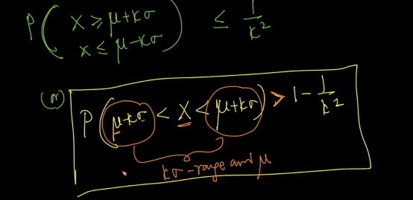

Should have >= and not >

What does the equation mean?

Given a Random Variable X for which we know, the mue and standard deviation are finite and the standard deviation is non zero. The probability that X lies between K standard deviation away from the mean is greater than 1- 1/k2

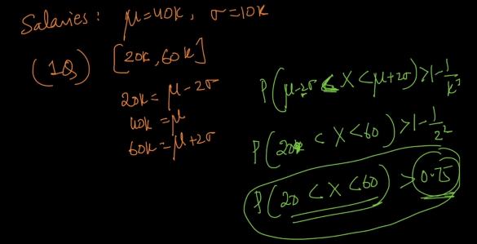

Example with salaries

### Discrete and Continuous Uniform distributions

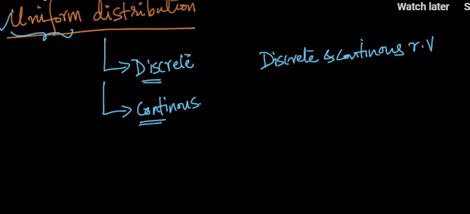

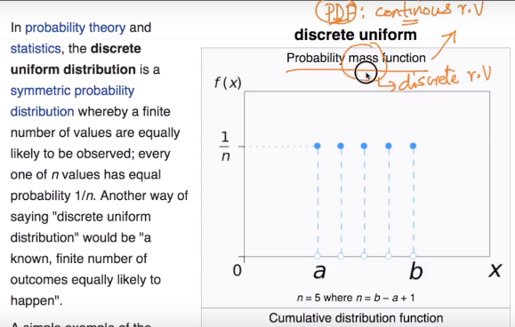

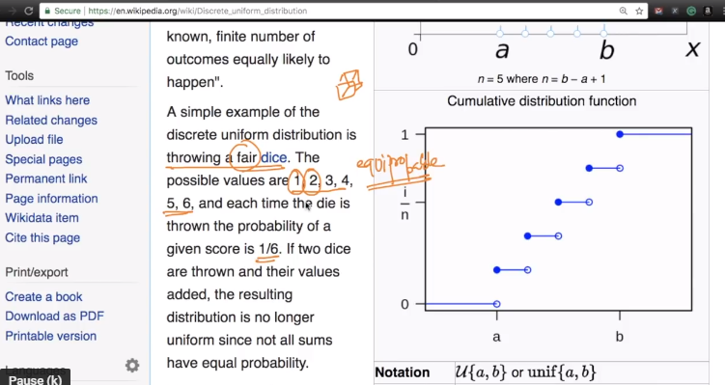

The Probability off getting any of these values is 6 and there are 6 outcomes i.e all 6 outcomes are equie probable

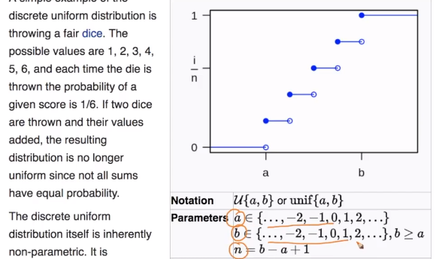

We have a and b as parameters for uniform distribution just like mue and sigma for Gaussian distribution

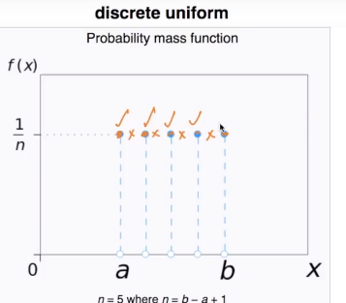

We can’t draw a line between points.

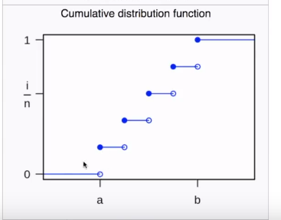

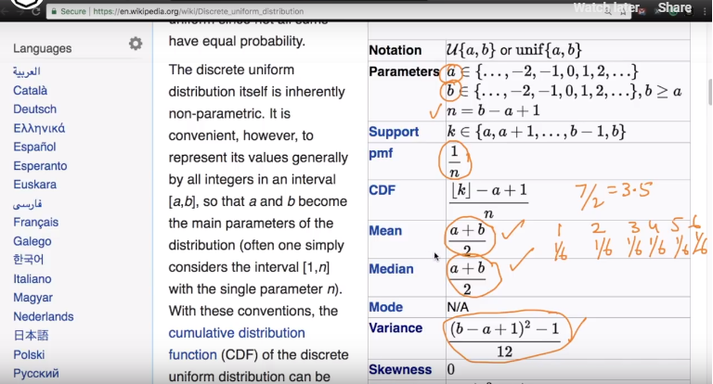

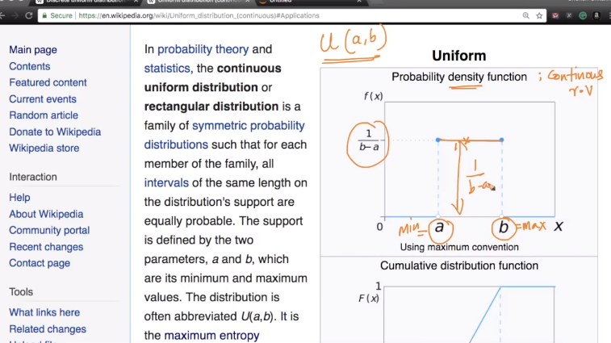

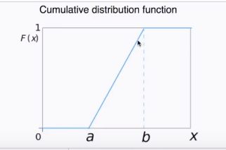

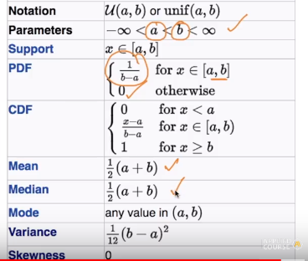

### How to randomly sample data points (Uniform Distribution)

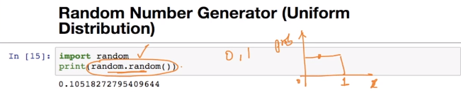

Most random number generators are uniformally distribution.

If I generate 100 numbers from this and plot distribution and this is how it would look like.

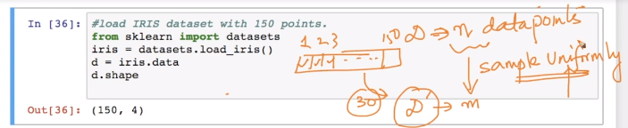

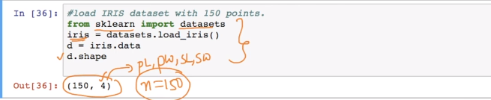

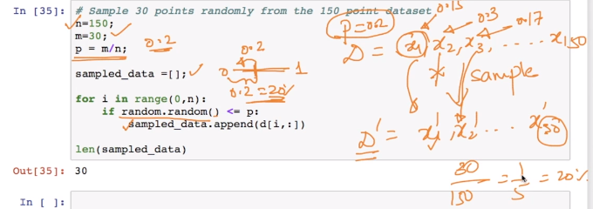

How does internally it is implemented in numpy or any other API.

Data set D is 150 points (x1,x2,x3,x4...x150)

Now I want to generate a Data set of D| of 30 points then what is the probability of each point that is in D to be part fo D| is 30/150 is almost equal to .2

### Bernoulli and Binomial Distribution

#### Bernoulli

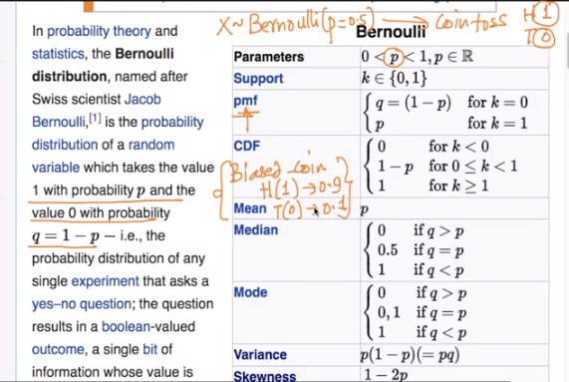

It’s the only parameter is p.

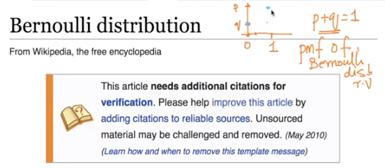

If we plot the distribution then this is how it looks like this

#### Binomial Distribution

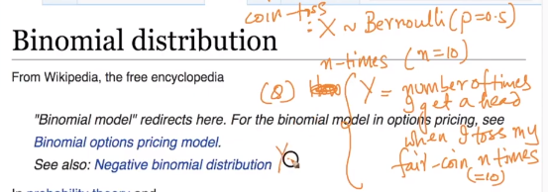

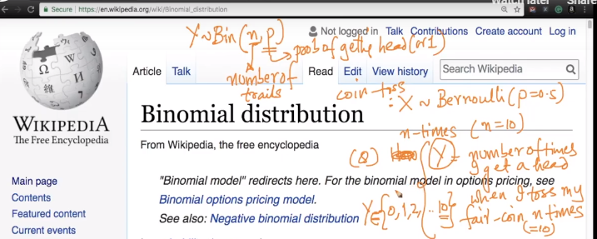

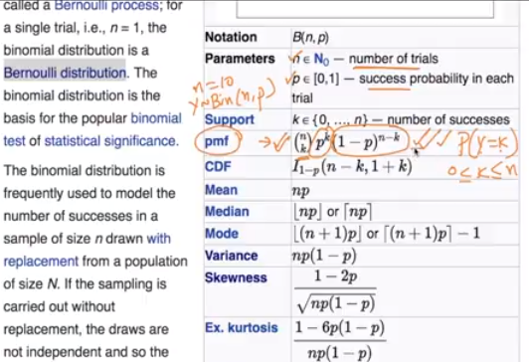

### Log-Normal Distribution

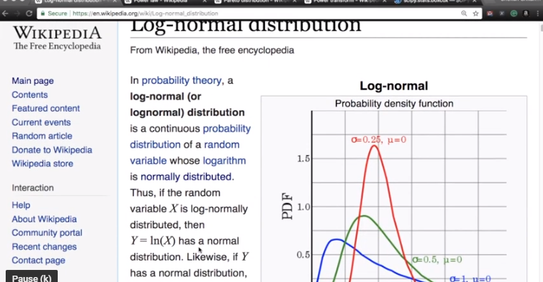

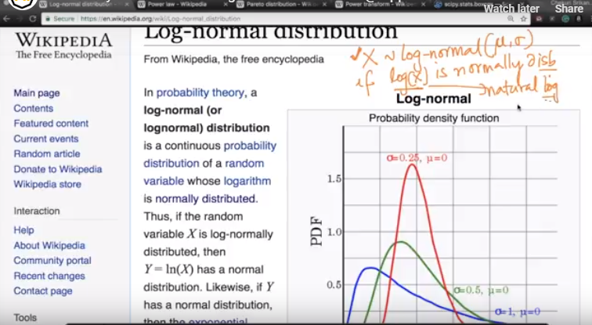

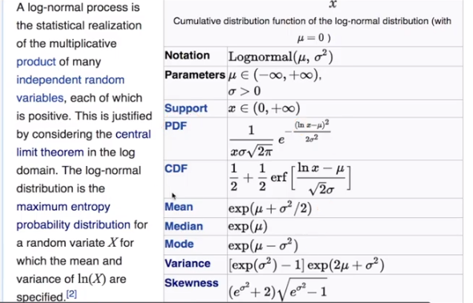

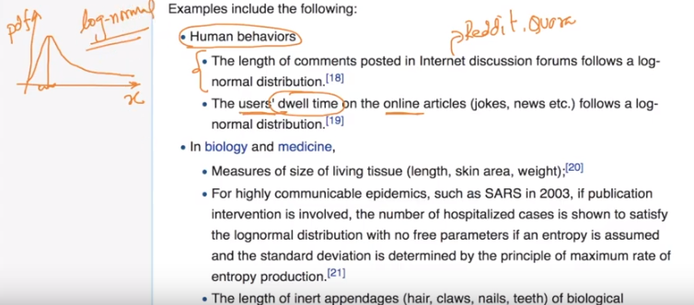

Most of the comments are short but as you see in the few are longer so the curve tailed more on the right.

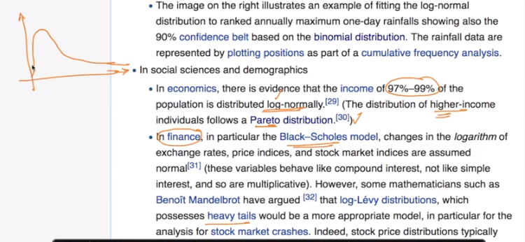

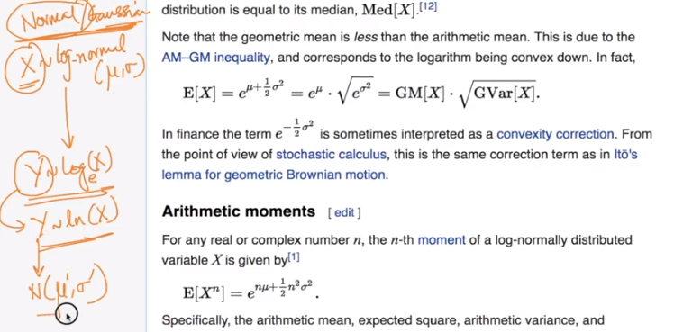

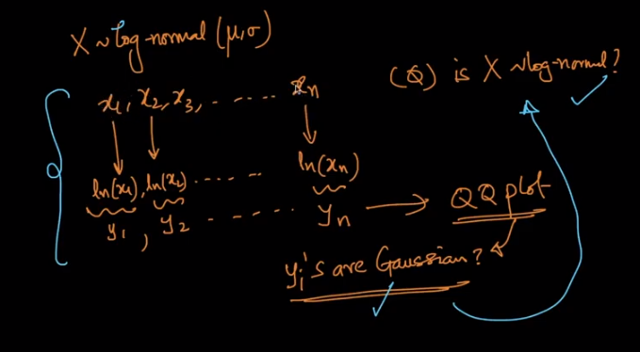

How do we test if X is log-normally distributed?

### Power law distribution

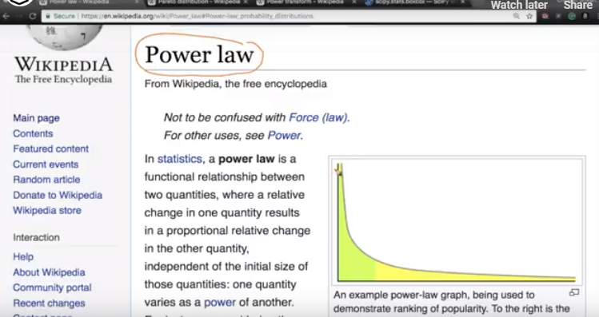

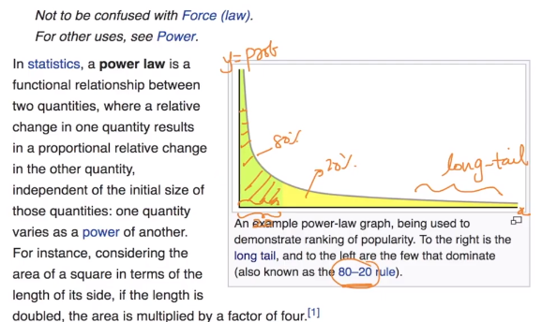

Lets image we have 2 variables x and y. If we suppose p is my probability value then it follows the

There is a very long tail for power.

It follows the 80-20 rule.

If a distribution follows the power law then that distribution is called the Perito Distribution

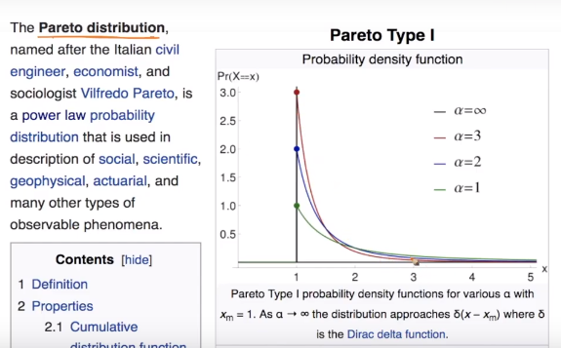

They are 2 parameters it has Xm

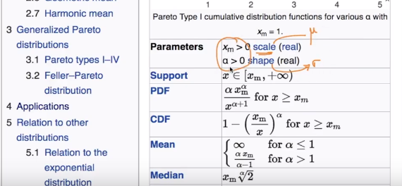

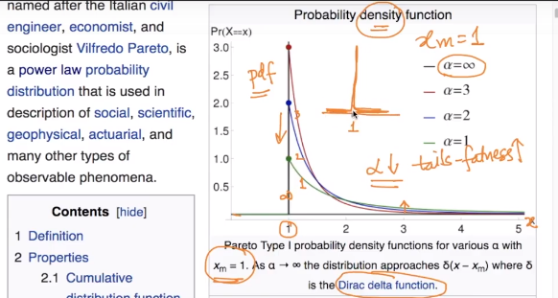

Let’s see how things change when we change the parameters.

Xm means that the peak is 1.

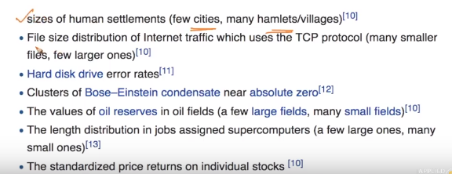

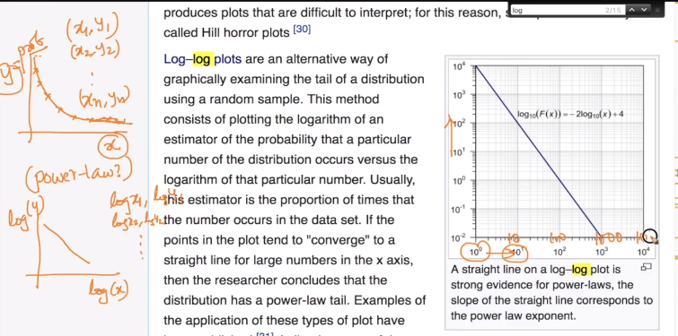

How do we identify if the distribution is following Power law?

log-log plot helps us in this aspect.

There are 2 ways to plot this as shown in the drawn picture and the other way is we change the axis as shown in the wiki plot.

If we get the straight line then it is most likely it follows the Power Law

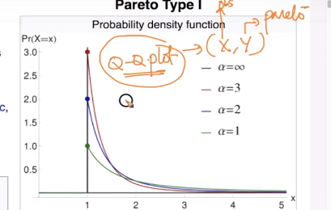

The other way if the distribution is following Power law?

### Box cox transform

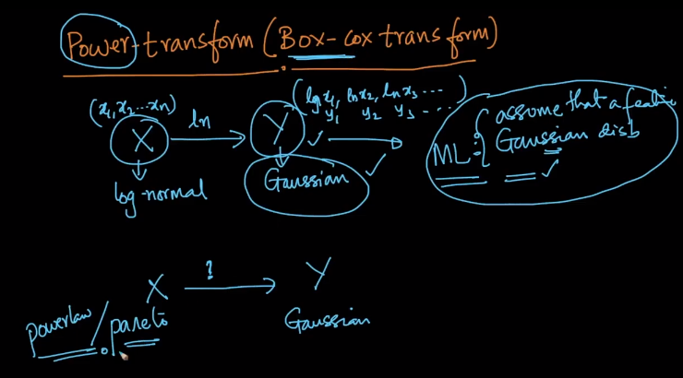

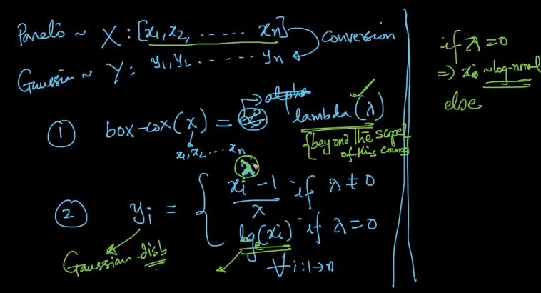

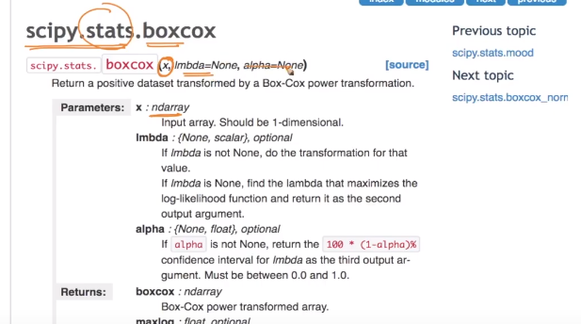

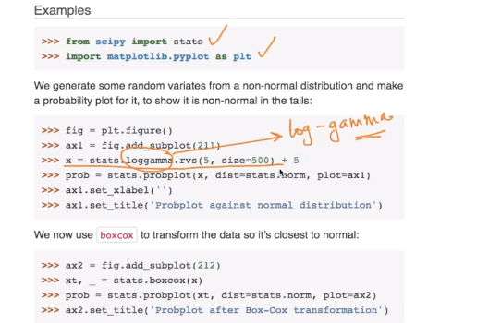

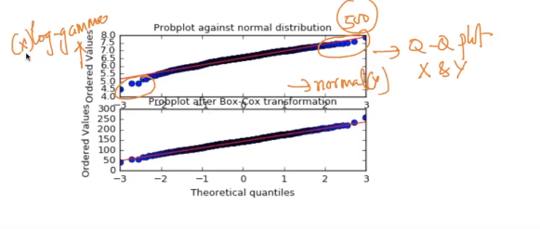

By seeing the Q-q plot we can easily say that they are not coming from the same distribution.

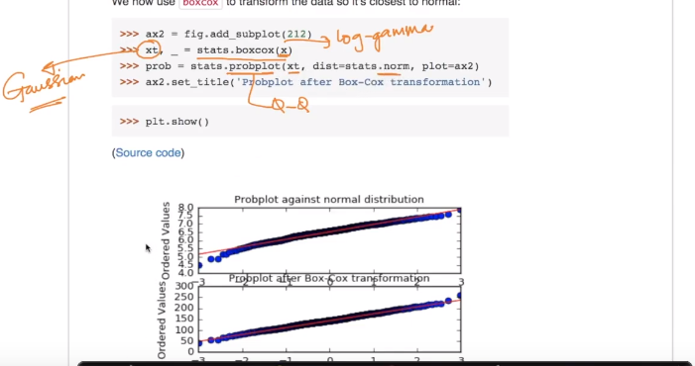

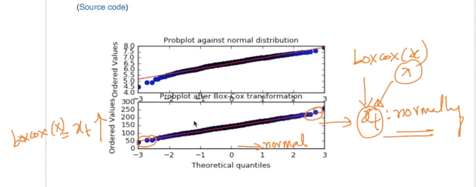

### Applications of non-gaussian distributions?